|  |  |
| --- | --- |
| **Department** | Engineering Mathematics and Physics |
| **Division** |  |
| **Academic Year** | 2019-2020 Preparatory |
| **Course name** | Computer |
| **Course code** | ECE001 |

|  |  |  |  |
| --- | --- | --- | --- |
|  | Name | Edu mail | B.N |
| 1 | Mohamed Mostafa abdalhamed | muhammed195893@feng.bu.edu.eg | 801 |

|  |  |
| --- | --- |
| Examiners committee | Signature |
| Dr.Ahmed Bayoumi |  |
| Dr.Shady Elmashad |  |
| Dr. Abdelhamid Attaby |  |

**Name:** Mohamed Mostafa abdalhamed

**B.N:** 801

**Topic**: Programing languages

**Application Brief:**

The first electrically powered, recognizably modern computers were created in the 1940s. The limited speed and memory capacity forced programmers to write manually tuned language assembly programmers. It was eventually realized that programming in assembly language required a great deal of intellectual effort**.**

An early proposal for a high-level programming language was Plankalkül, developed between 1943 and 1945 by Konrad Zeus for his Z1 machine but not implemented at the time.

In the early 1950s, the first functioning programming languages were written designed to communicate instructions to a computer. The Short Code, proposed in 1949 by John Mauchly, was one of the first high-level languages ever developed for an electronic computer. Short-code sentences, unlike computer code, expressed mathematical expressions in understandable form. Just the same, Each time the program was running it had to be translated into machine code, making the process much slower than running the identical machine code.

In 1954, a team led by John Backus invented FORTRAN at IBM; it was the first widely used, high-level general purpose programming language to have a functional implementation, rather than just a paper design. When FORTRAN was first introduced it was regarded with suspicion because of bugs, implementation delays, And the comparative effectiveness of assembled "hand-coded" programmes. However, in a rapidly changing hardware market; gradually the language became known for its performance. It is still a popular high-performance computing language, and is used for programs that benchmark and rank the fastest supercomputers in the world.

**Source Code:**

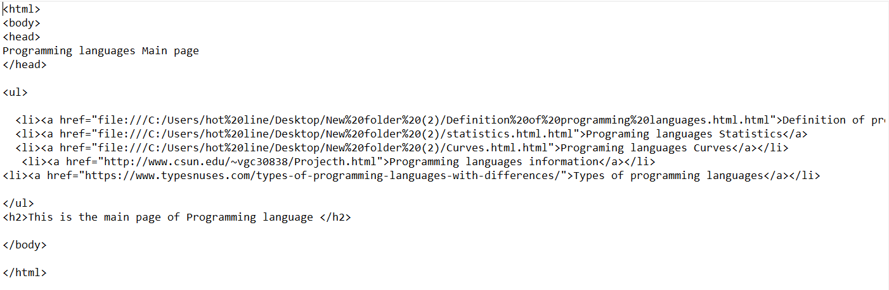

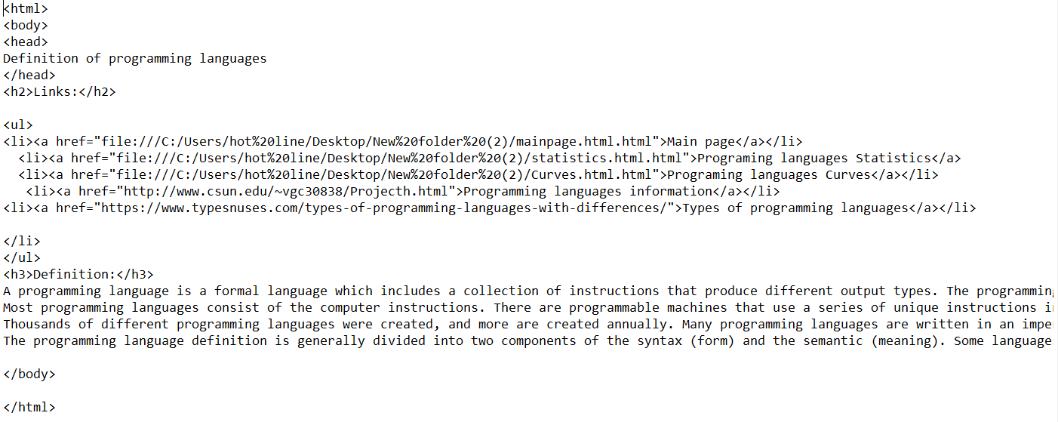

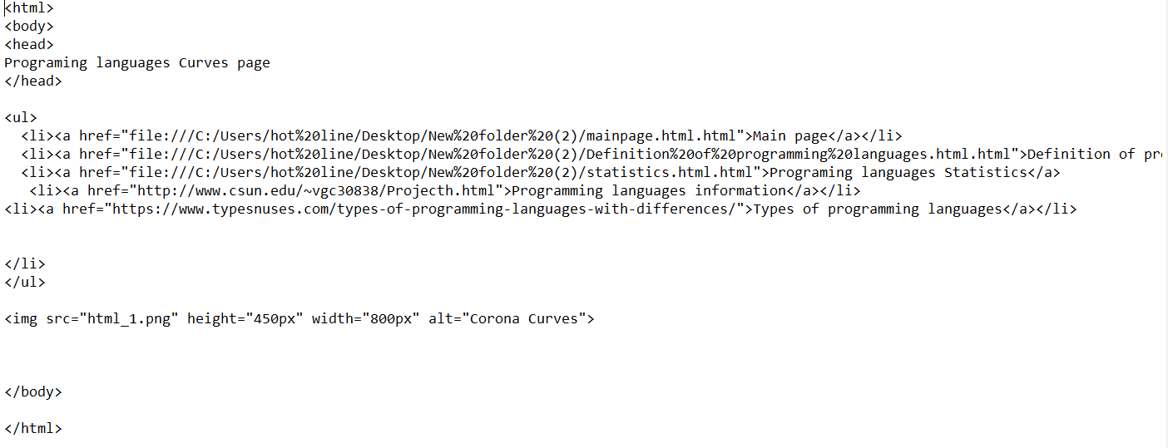

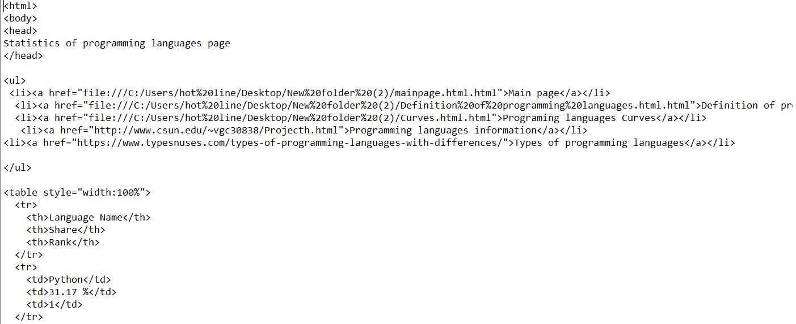

**Screenshots:**

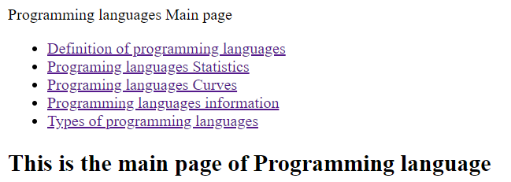

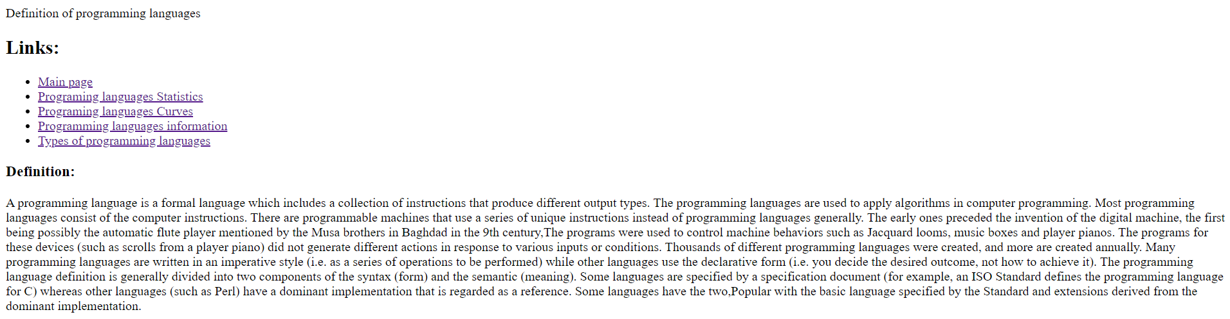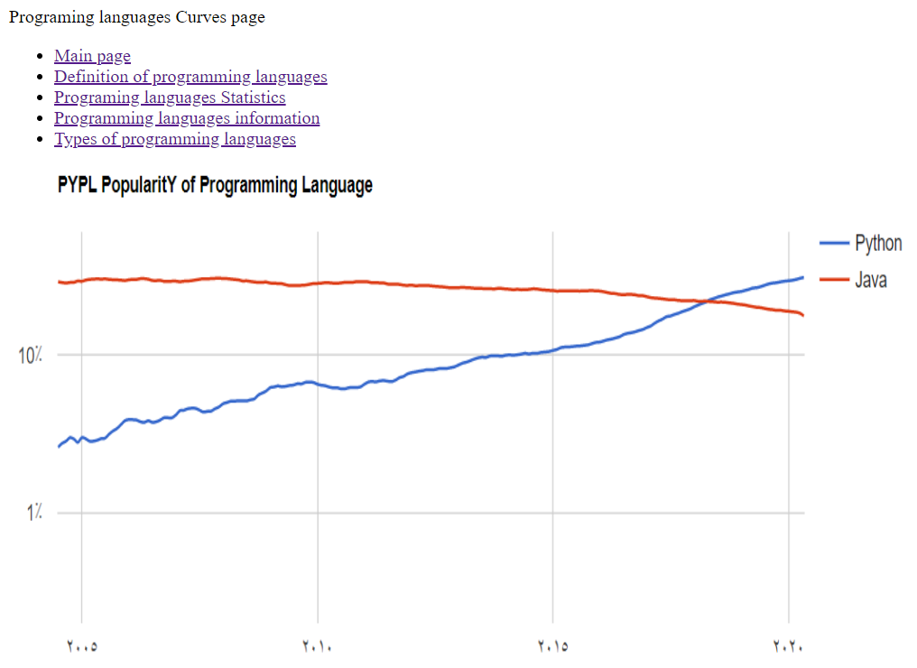

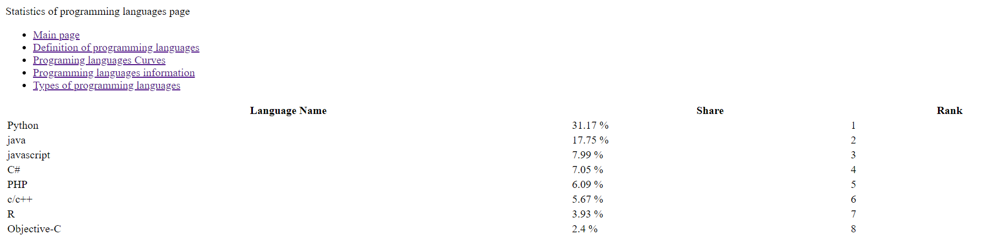

**References**

1. <http://www.csun.edu/~vgc30838/Projecth.html>
2. <https://online.maryville.edu/blog/programming-languages-for-software-developers/>
3. <https://cpsc.yale.edu/research/programming-languages>
4. <https://www.washington.edu/accesscomputing/what-are-some-examples-accessible-programming-languages>